# ECE545 HW4 Report

# Yu Li

1. Indextable display

The picture tested is

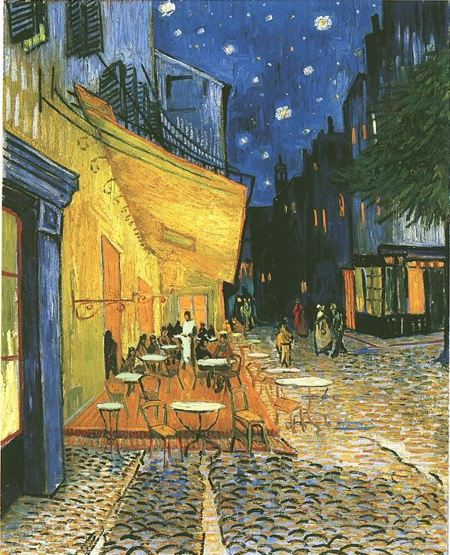

The result picture is

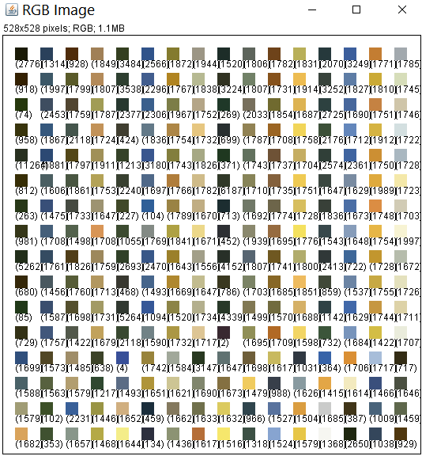

I divide original picture to three channels(R,G,B), then deal with them separately, then combine them together.

1. Color Transfer

Pictures used are

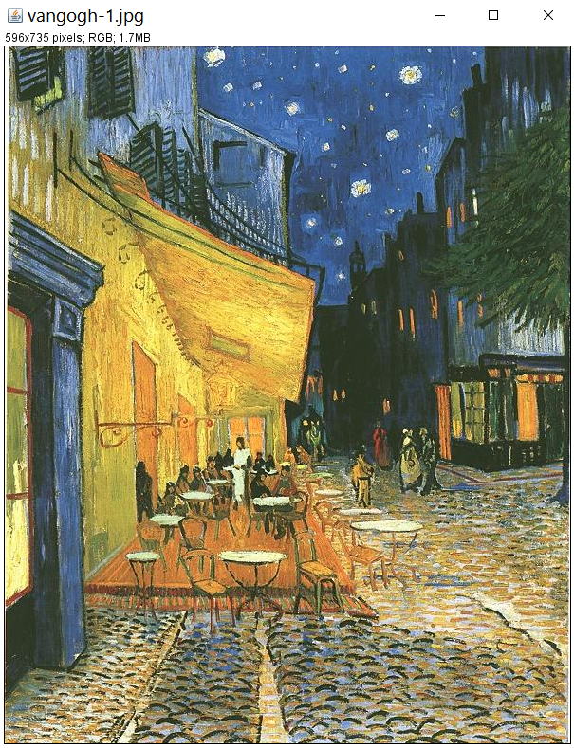

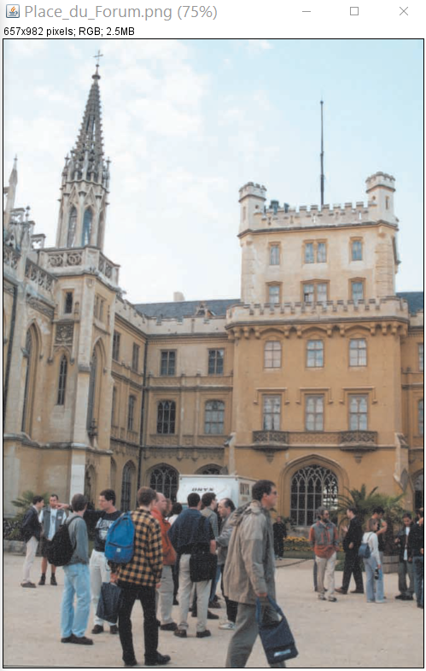

The result is

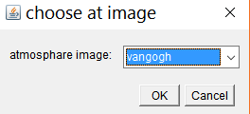

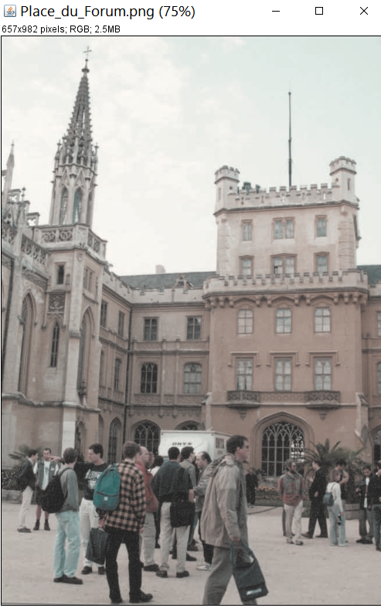

The atmosphere picture is the first one, and the picture to deal with is the second one.By using the method given in paper ColorTransfer.pdf, we can get this result.

1. DFT 2D

The original picture is

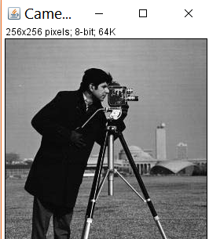

The result is like

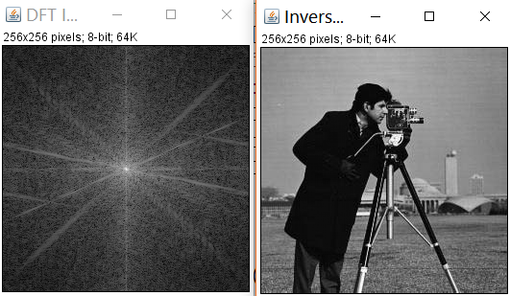

The first picture is the DFT result of original picture and there are three functions reverse DFT 2D and DFT 2D and centering which is used to center it by swap 4corners to center after DFT 2D

1. Motion deblur

The original picture and processed pictures are, the left is original, the right is processed one. We can get this result by implementing the reverse of Gaussian filter many times and setting proper sigma.

